# Ideation Phase

**Define the Problem Statements**

|  |  |
| --- | --- |
| Date | 19 September 2022 |
| Team ID | PNT2022TMID12654 |
| Project Name | Project - IOT Based Safety Gadget For Child  Safety Monitoring & Notification |
| Maximum Marks | 2 Marks |

# Problem Statement :

Around the world, many children disappear each year and are not found. Runaways, parental abductions or kidnappings by others, these acts are difficult to prevent and have dire consequences on the children involved. Nowadays, crime rate associated with children keeps increasing due to which draws people attention regarding child safety.

# Example:

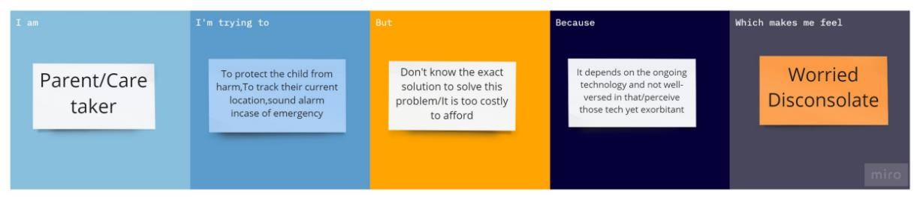

|  |  |  |  |  |  |
| --- | --- | --- | --- | --- | --- |
| **Problem Statement (PS)** | **I am (Customer)** | **I’m trying to** | **But** | **Because** | **Which makes me feel** |
| PS-1 | Parent | Protect the child from harm. | I don’t know the exact solution to solve this  problem. | It depends on the ongoing technology | Worried |